CSE3002 – Internet and Web Programming

Lab – 4

Pinni Venkata Abhiram

20BAI1132

Question – 1

Read the number and check whether it is odd or even in the click event of button titled as odd.

Question – 2

Read the number and check whether the given number is prime number or not and display the same in 2nd text field in the click event of prime button.

Question – 3

The teacher teaches number system to the students. The number systems are binary , octal and hexadecimal. Teacher gave home work to the students to do conversion. So develop a minimal web application to read the number in decimal format and display in the corresponding number format based on the click event of the user.

Answer

The above three questions are done in single HTML and JS file

For this question I’m importing a JS file which contains the code required for the above three questions instead of writing all the JS code in a single script tag

HTML Code

<!DOCTYPE html>

<html lang="en">

<head>

    <meta charset="UTF-8">

    <meta http-equiv="X-UA-Compatible" content="IE=edge">

    <meta name="viewport" content="width=device-width, initial-scale=1.0">

    <title>JS Exercises</title>

</head>

<body style="margin: 50px; border: 1px solid; padding: 40px; background-color: #D6E5FA">

    <script src="1.js" language = "Javascript"></script>

    <h1 style="font-size: x-large; font-family: 'Lucida Sans', 'Lucida Sans Regular', 'Lucida Grande', 'Lucida Sans Unicode', Geneva, Verdana, sans-serif;"> Even and odd calculator using JS </h1>

    <form name = "f1">

        <input type="text" name="t1"><br><br><br>

        <input type="button" value="Odd" name="b1" onclick = "function1()" >

    </form>

    <br><br><br>

    <hr style="border: 1px solid;">

    <br><br>

    <h1 style="font-size: x-large; font-family: 'Lucida Sans', 'Lucida Sans Regular', 'Lucida Grande', 'Lucida Sans Unicode', Geneva, Verdana, sans-serif;"> Check whether the given number is prime or not </h1>

    <form name = "f2">

        <input type="text" name="t2">

        <input type="text" name="t3">

        <br><br><br>

        <input type="button" value="Prime" onclick = "function2()" >

    </form>

    <br><br>

    <hr style="border: 1px solid;">

    <br><br>

    <h1 style="font-size: x-large; font-family: 'Lucida Sans', 'Lucida Sans Regular', 'Lucida Grande', 'Lucida Sans Unicode', Geneva, Verdana, sans-serif;"> Conversion of a number to Hexadecimal , Octal and Binary forms</h1>

    <form name = "f3">

        <input type="text" name="t4">

        <br><br><br>

        <input type="button" value="Submit number" onclick = "function3()" >

        <p id = "demo"></p>

    </form>

</body>

</html>

JavaScript Code

function function1()

{

    const v = parseInt(document.f1.t1.value);

    if (v % 2 == 0)

    {

        alert("Even number");

    }

    else

    {

        alert("Odd number");

    }

}

function function2()

{

    const x = parseInt(document.f2.t2.value);

    let count = 0;

    for (let i = 1 ; i < x ; i++)

    {

        if (x % i  == 0)

        {

            count += 1;

        }

    }

    if (count == 1)

    {

        alert("Prime number");

        document.f2.t3.value = "Prime Number";

    }

    else

    {

        alert("Not a prime number");

        document.f2.t3.value = "Not a Prime Number";

    }

}

function function3()

{

    const xo = parseInt(document.f3.t4.value);

    let hex = xo.toString(16);

    let bin = xo.toString(2);

    let oct = xo.toString(8);

    document.getElementById("demo").innerHTML = "Hexadecimal Value is " + hex + "<br>" + "Binary Value is " + bin + "<br>" + "Octal Value is " + oct ;

    document.getElementById("demo").style.fontFamily = "Verdana,bold,arial";

    document.getElementById("demo").style.fontWeight = "900";

}

Output

Question – 1

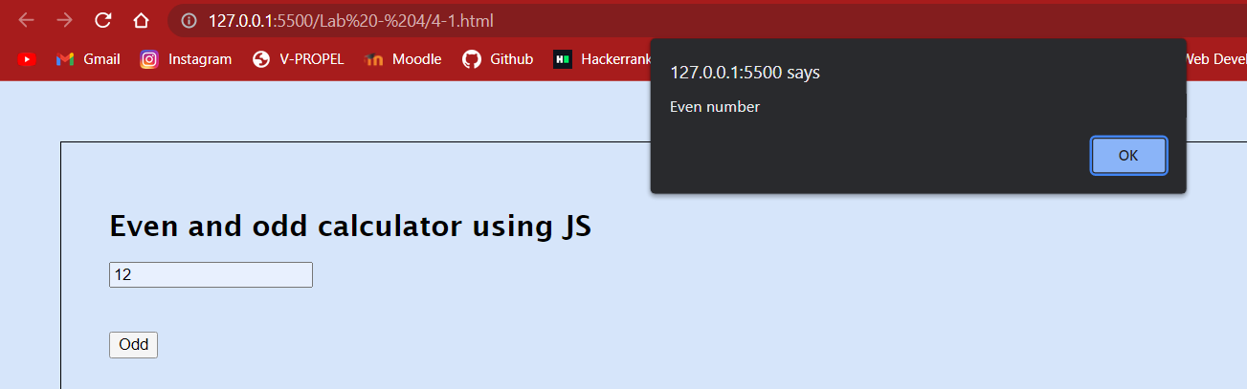

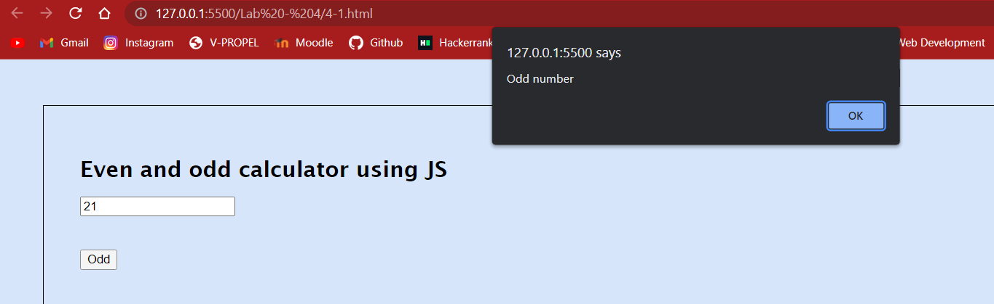

Question – 2

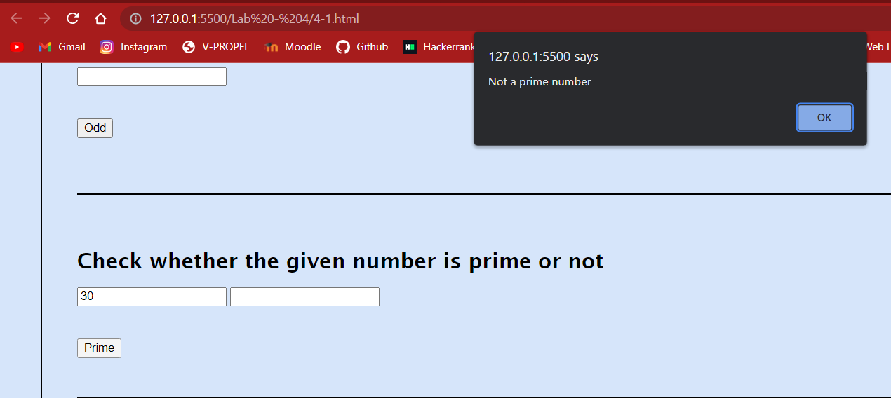

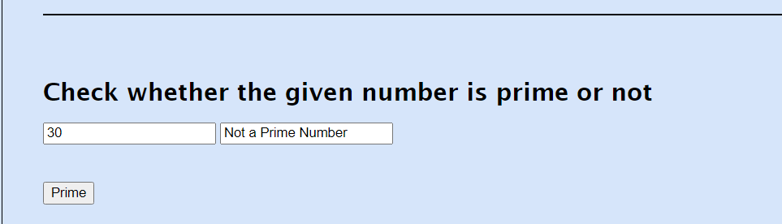

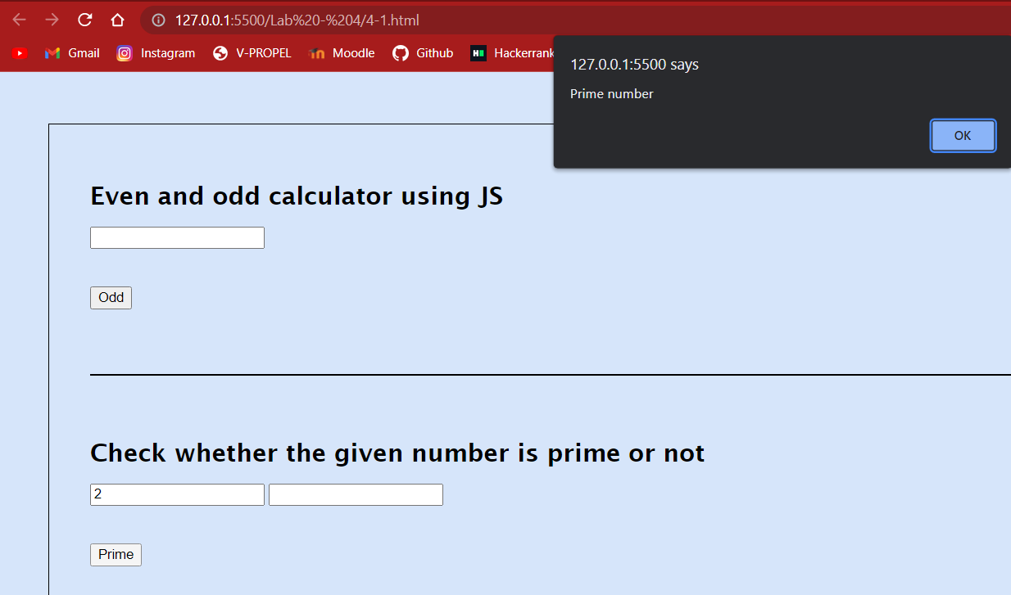

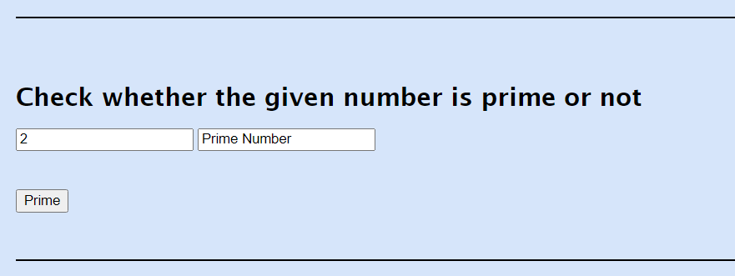

Question – 3

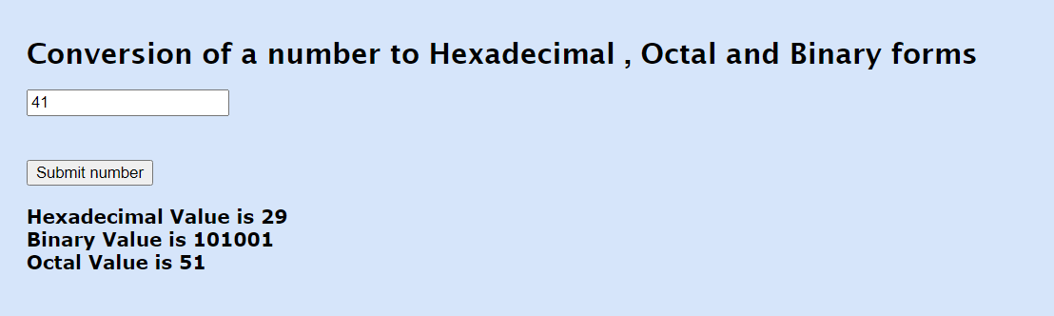

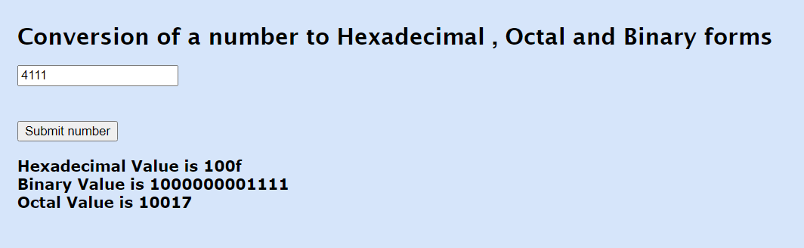

Question – 4

Design a webpage to include the video of addition of two numbers tutorial to the kids. In the same page provide the facility for checking the knowledge gained by the student.

Answer

HTML Code

<!DOCTYPE html>

<html lang="en">

<head>

    <meta charset="UTF-8">

    <meta http-equiv="X-UA-Compatible" content="IE=edge">

    <meta name="viewport" content="width=device-width, initial-scale=1.0">

    <title>Addition of two numbers</title>

</head>

<body style="margin: 50px; border: 1px solid; padding: 40px; background-color: #D6E5FA">

    <script src="2.js" language = "Javascript"></script>

    <h1 style="font-size: x-large; font-family: 'Lucida Sans', 'Lucida Sans Regular', 'Lucida Grande', 'Lucida Sans Unicode', Geneva, Verdana, sans-serif;"><u>Addition of Numbers</u></h1>

    <br><br>

    <embed type="video/webm" src="Add.mp4" width="600" height="500">

    <br><br>

    <h3 style="font-family: Arial, Helvetica, sans-serif;">Test your knowledge with below questions</h3>

    <form name = "f1" style="font-size: x-large;">

        24 + 45 =

        <input type="text" size="4" maxlength="4" name="t1"><br><br>

        56 + 105 =

        <input type="text" size="4" maxlength="4" name="t2"><br><br>

        42 + 63 =

        <input type="text" size="4" maxlength="4" name="t3"><br><br>

        <input type="button" value="Submit Answers" name="b1" onclick = "function1()">

    </form>

    <br><br>

    <div id = "one"></div>

    <div id = "two"></div>

    <div id = "three"></div>

    <br><br>

    <hr style="border: 1px solid;">

    <br><br>

    <h3 style="font-family: Arial, Helvetica, sans-serif;">Make your own question and try getting the answer</h3>

    <form name = "f2" style="font-size: x-large;">

        <input type="text" size="4" maxlength="4" name="t4"> +

        <input type="text" size="4" maxlength="4" name="t5"> =

        <input type="text" size="4" maxlength="4" name="t6">

        <br><br>

        <input type="button" value="Submit Question and Answer" name="b1" onclick="function2()">

    </form>

    <br><br>

    <div id="four"></div>

</body>

</html>

JavaScript Code

function function1()

{

    const x = parseInt(document.f1.t1.value);

    const y = parseInt(document.f1.t2.value);

    const z = parseInt(document.f1.t3.value);

    if (x == 69)

    {

        document.getElementById("one").innerHTML = "Answer for first question is correct";

        document.getElementById("one").style.fontFamily = "Verdana,bold,arial";

        document.getElementById("one").style.fontWeight = "900";

    }

    else

    {

        document.getElementById("one").innerHTML = "Answer for first question is wrong";

        document.getElementById("one").style.fontFamily = "Verdana,bold,arial";

        document.getElementById("one").style.fontWeight = "900";

    }

    if (y == 161)

    {

        document.getElementById("two").style.fontFamily = "Verdana,bold,arial";

        document.getElementById("two").style.fontWeight = "900";

        document.getElementById("two").innerHTML = "Answer for second question is correct";

    }

    else

    {

        document.getElementById("two").style.fontFamily = "Verdana,bold,arial";

        document.getElementById("two").style.fontWeight = "900";

        document.getElementById("two").innerHTML = "Answer for second question is wrong";

    }

    if (z == 105)

    {

        document.getElementById("three").style.fontFamily = "Verdana,bold,arial";

        document.getElementById("three").style.fontWeight = "900";

        document.getElementById("three").innerHTML = "Answer for third question is correct";

    }

    else

    {

        document.getElementById("three").innerHTML = "Answer for third question is wrong";

        document.getElementById("three").style.fontFamily = "Verdana,bold,arial";

        document.getElementById("three").style.fontWeight = "900";

    }

}

function function2()

{

    const x = parseInt(document.f2.t4.value);

    const y = parseInt(document.f2.t5.value);

    const z = parseInt(document.f2.t6.value);

    const o = x + y;

    if (x + y == z)

    {

        document.getElementById("four").innerHTML = "Answer for question is correct";

        document.getElementById("four").style.fontFamily = "Verdana,bold,arial";

        document.getElementById("four").style.fontWeight = "900";

    }

    else

    {

        document.getElementById("four").innerHTML = "Answer for third question is wrong , " + "The correct answer is " +  o ;

        document.getElementById("four").style.fontFamily = "Verdana,bold,arial";

        document.getElementById("four").style.fontWeight = "900";

    }

}

Output

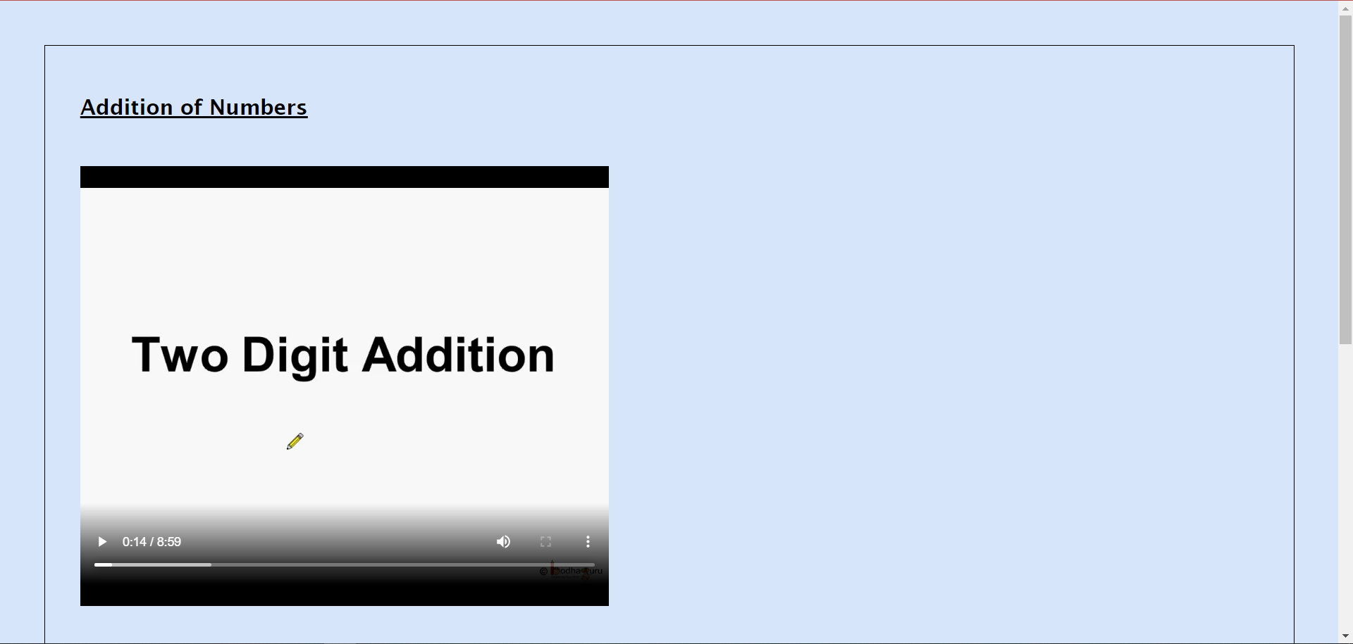

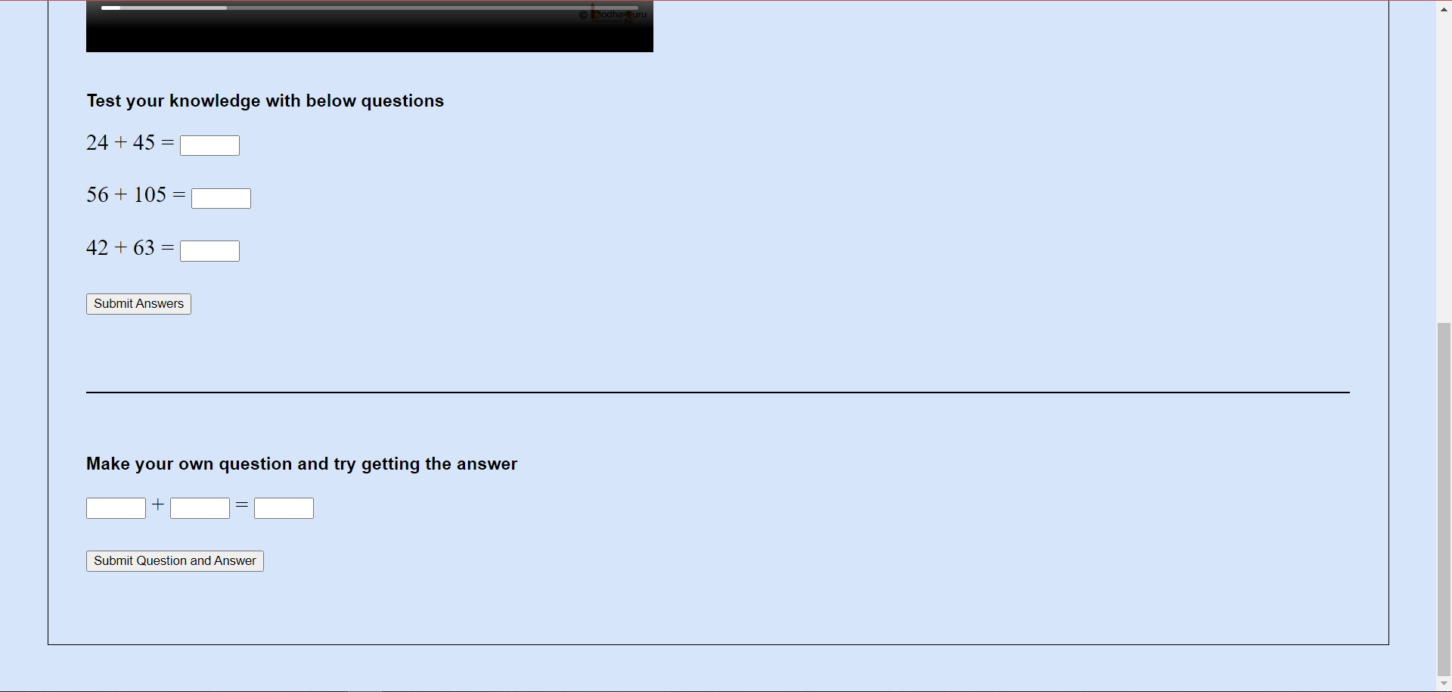

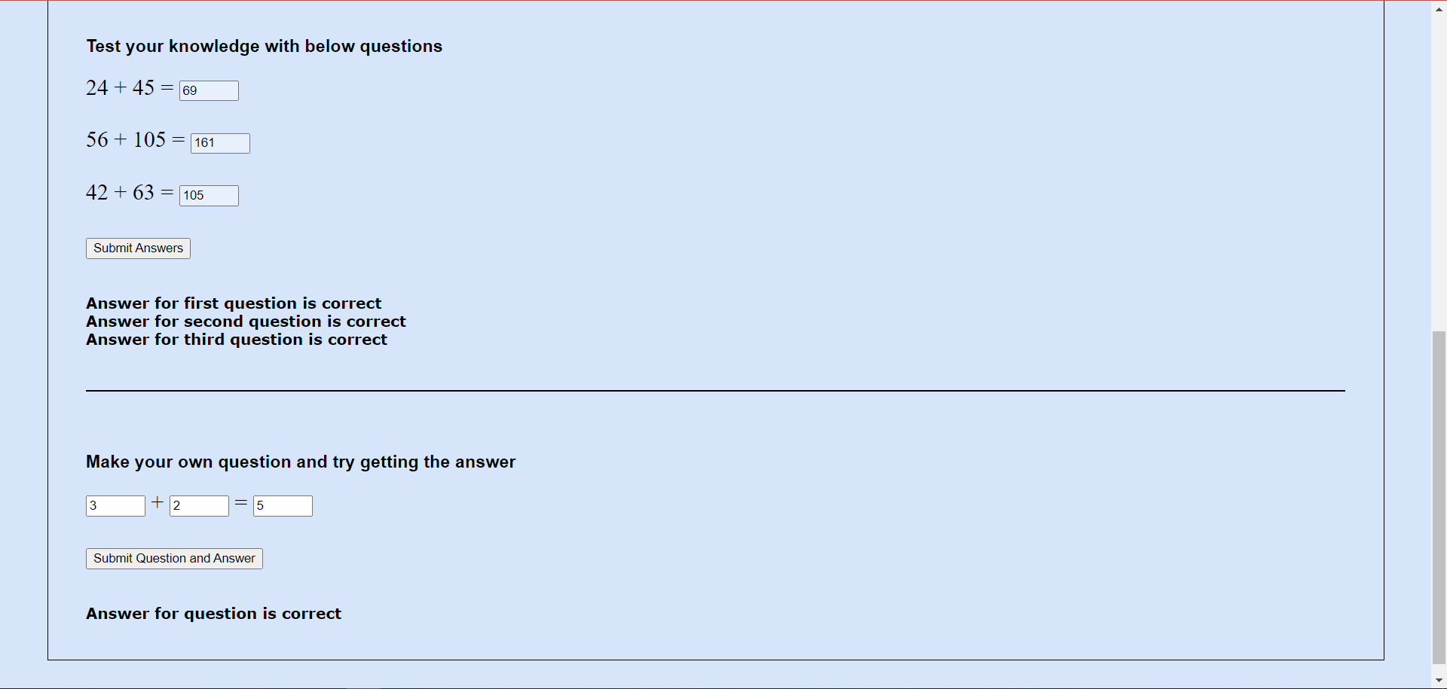

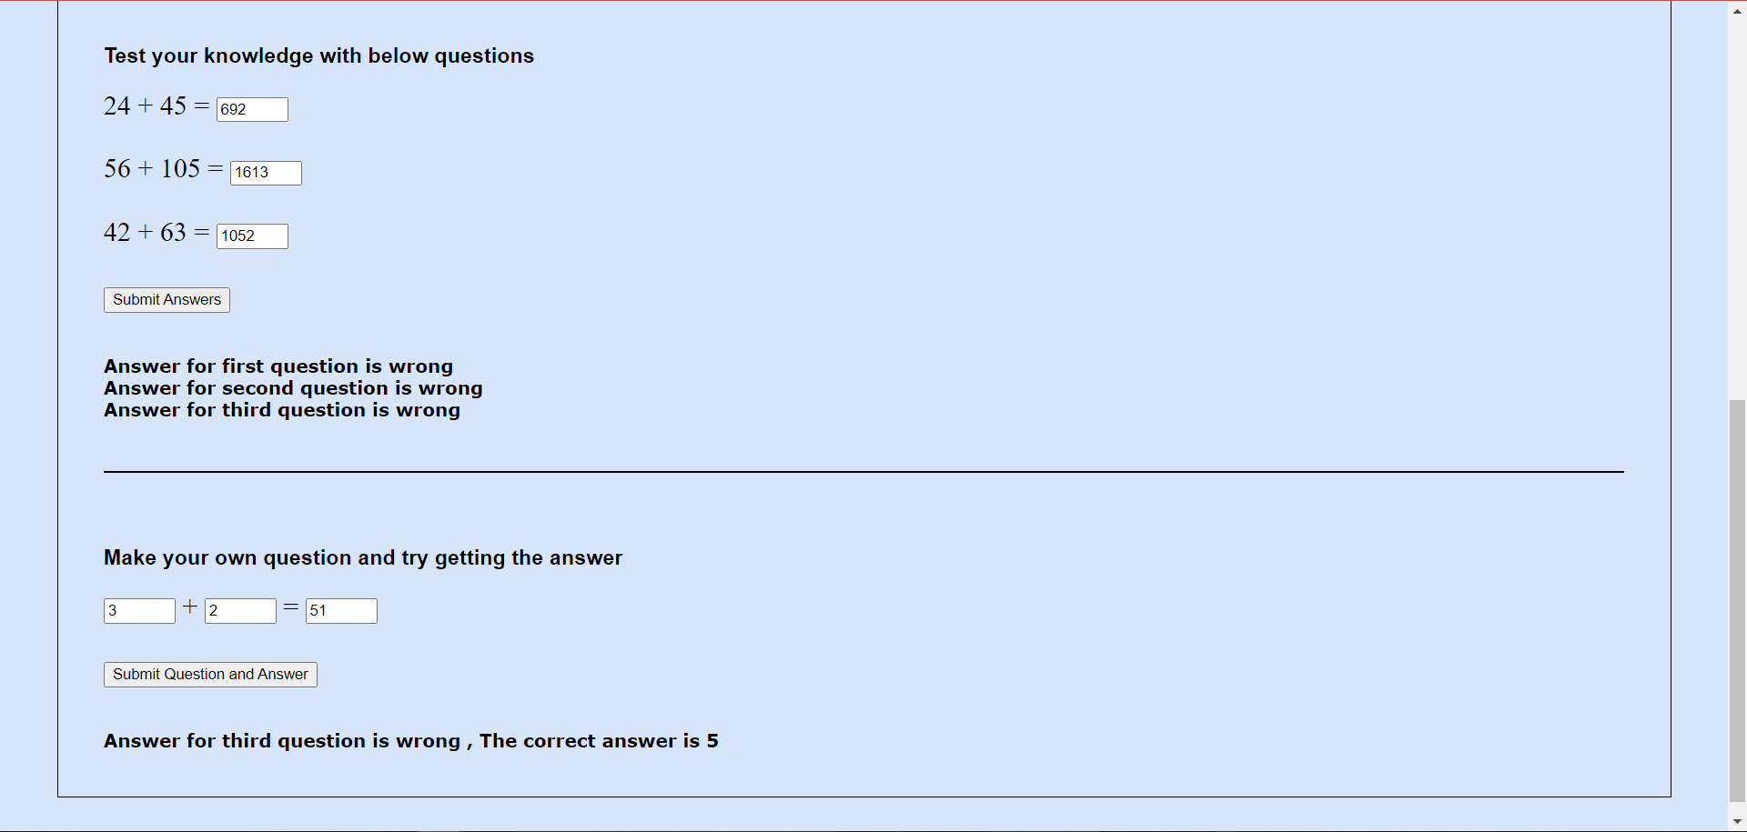

Thank you ma’am

Pinni Venkata Abhiram

20BAI1132